# **Day 1 topics**

USER STORY:

A user story is a tool used in Agile software development to capture a description of a software feature from an end-user perspective. A user story describes the type of user, what they want and why. A user story helps to create a simplified description of a requirement.

it is accompanied by acceptance criteria

Overall, user stories serve as a communication tool between the development team and stakeholders, keeping the focus on delivering features that directly address user needs.

Acceptance Criteria give us a set of rules or provides a certain criteria that we must ensure for the user story, only once this acceptance criteria is fulfilled only then we can begin the development.

Acceptance criteria are specific conditions or requirements that a product or service must meet in order to be accepted by a customer, user, or stakeholder.

They are typically defined during the planning phase of a project or development cycle, and they serve as the basis for evaluating whether the deliverable meets the expectations and needs of the stakeholders.

A.C are a set of conditions a product must meet to be accepted by a user, customer,or other system.

it is written by a business analyst.

User Story Template:

User stories only capture the essential elements of a requirement:

Who it is for?

What it expects from the system?

Why it is important (optional?)?

"As a [type of user], I want [a goal] so that [a reason].

EXAMPLE:

1)

As an online shopping addict,

I want to be able to filter search results by price range

So that I can find products within my budget more easily.

Acceptance Criteria:

1. On the search results page, there should be a filter option labeled "Price Range".
2. The price range filter should allow me to input minimum and maximum price values.
3. After setting the price range filter and applying it, the search results should update accordingly to display only products within the specified price range.
4. If no products fall within the selected price range, a message should be displayed indicating no results found.

Tasks:

Design the UI for the price range filter.

Implement backend functionality to filter search results based on price range.

Develop the logic to update search results upon applying the price range filter.

Create a error to display a message when no results are found within the specified price range.

2)

As a registered user,

I want to share my favourite posts on social media platforms

So that I can engage with my friends and expand the reach of interesting content.

Acceptance Criteria:

1. When viewing a post, there should be a "Share" button visible.
2. Clicking on the "Share" button should display a list of social media platforms for sharing, such as Facebook, Twitter, and LinkedIn.
3. Upon selecting a social media platform, the user should be prompted to log in if not already logged in to that platform.
4. After logging in, the user should be able to customize the accompanying message before sharing the post.
5. The shared post should include a link back to the original post on the platform.
6. Once shared, the user should receive a confirmation message indicating successful sharing.

**Epics: -**

Epics are large bodies of work that can be broken down into a number of smaller tasks (called stories).

In a sense, stories and epics in agile are similar to stories and epics in film or literature. A story is one simple narrative; a series of related and interdependent stories makes up an epic.

The same is true for your work management, where the completion of related stories leads to the completion of an epic.

When several epics themselves share a common goal, they are grouped together under a still-broader business objective, called a theme.

**Theme epic stories**

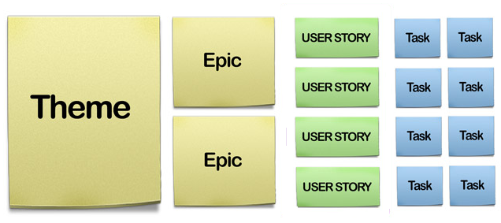

Initiatives are the overarching goals that an organisations is working towards. They are similar to themes, but whereas themes focus on a specific area or focus, initiatives focus on the big picture. For example, an initiative for a SaaS platform might be "Becoming the leading provider of cloud-based analytics solutions."

Initiatives are used to align the efforts of different teams and departments towards a common goal. They also serve as a way to measure the success of an organisations and track progress over time.

* While both**Themes and Initiatives**serve similar purposes, the key difference lies in their focus. Themes focus on aligning Epics with a specific area or focus, while Initiatives focus on aligning Epics with a specific business goal. By understanding and utilising both Themes and Initiatives, organisations can ensure a more strategic approach to product development and achieve their business goals.

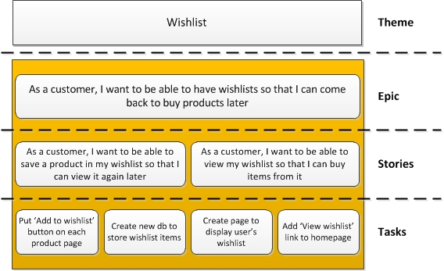

**Invest:**

Invest criteria help ensure that user stories are clear, concise, and effective at delivering valuable working software early and often.

Independent: User stories should be self-contained and not dependent on other user stories unless there is a need.

Negotiable: User stories should be open to discussion and negotiation.

Valuable: User stories should provide value to the end user.

Estimable: User stories should be able to be estimated by the development team.

Small: User stories should be small enough to be completed within a single iteration or sprint.

Testable: User stories should have clear acceptance criteria that can be used to test the functionality.

By following these criteria, teams can create user stories that are more likely to meet the needs of users, be easily understood by the development team, and be efficiently implemented.

Example of a user story that follows the INVEST criteria:

**User Story:** As a registered user, I want to be able to reset my password so that I can regain access to my account if I forget it.

**Independent**: This user story appears to be independent because it focuses on a single functionality (password reset) and does not seem to be directly reliant on other user stories. It can be worked on without needing to complete other stories first.

**Negotiable**: While the user story outlines the basic functionality required (password reset), it still leaves room for negotiation and discussion. For instance, the specifics of the user interface, security measures, and notification system can be negotiated between the development team and the product owner.

**Valuable**: The user story clearly provides value to the end-user by allowing them to regain access to their account in case they forget their password. This functionality aligns with the needs of the user and contributes to a positive user experience.

**Estimable**: The user story is clear and specific enough that the development team can estimate the effort required to implement it. The team can break down the tasks involved, such as implementing the password reset functionality, designing the user interface, and testing the feature.

**Small**: This user story seems appropriately sized and focused. It addresses a specific need without trying to incorporate unrelated features. It should be achievable within a single iteration or sprint, making it small enough to be manageable.

**Testable**: The user story includes clear acceptance criteria: the ability for a registered user to initiate the password reset process and successfully reset their password. These criteria are measurable and verifiable, allowing the team to determine when the story is complete.

By following the INVEST principles, teams can write user stories that are more likely to meet the needs of users, be easily understood by the development team, and be efficiently implemented. F

**3 c’s:**ar?

the "3 C's" typically refer to the three key components that make up a well-formed user story. These components are:

1. **Card (or Conversation)**: This is the physical or digital card that contains the user story. It serves as a placeholder for a conversation between the stakeholders (usually the product owner, development team, and any other relevant parties) about the feature or functionality described in the story.
2. **Conversation (or Confirmation)**: This component represents the discussions and clarifications that happen around the user story. It involves the stakeholders discussing the details, acceptance criteria, and any questions or concerns related to the story. This conversation ensures a shared understanding of what needs to be built.
3. **Confirmation (or Criteria)**: This is the set of acceptance criteria or conditions of satisfaction that define when the user story is considered complete. These criteria outline the specific behaviors or outcomes that the system should exhibit to meet the user's needs. They serve as a way to validate that the implementation fulfills the requirements of the story.

These three components help ensure that user stories are effectively communicated, understood, and implemented by the development team. They emphasize collaboration, clarity, and shared understanding among stakeholders throughout the software development process.

**Scrum:**

Scrum is a framework used in agile project management for organizing, managing, and delivering complex work, primarily in software development but also in various other fields.

It provides a structured approach to product development, emphasizing iterative and incremental progress, collaboration, and flexibility in responding to change.

The term "Scrum" originated from rugby, In rugby, the team comes together in what they call a scrum to work together to move the ball forward.

In this context, Scrum is where the team comes together to move the product forward.

scrum describes a set of meetings, tools, and roles that work in concert to help teams structure and manage their work.

Key components of Scrum include:

Roles: Scrum defines three primary roles: Product Owner, Scrum Master, and Development Team.

The Product Owner represents the stakeholders and is responsible for managing the product backlog.

The Scrum Master facilitates the Scrum process and helps the team adhere to its practices.

The Development Team consists of professionals who deliver the product increment.

Events: Scrum events are time-boxed activities that define the cadence of the framework.

These include Sprint Planning, Daily Stand-up (or Daily Scrum), Sprint Review, and Sprint Retrospective.

The Sprint itself is a time-boxed iteration during which development occurs.

Artifacts: Scrum defines several artifacts to support transparency and communication.

The Product Backlog is an ordered list of all desired work on the product. The Sprint Backlog is a subset of the Product Backlog items selected for the Sprint, along with a plan for delivering them.

The Increment is the sum of all the completed Product Backlog items at the end of a Sprint.